Project Functional Plan

Assessment 2

Kieran Abelen

Contents

Objectives 2

Test approach and assumptions 2

Features and Functionality to Test 3

Expected results of Test 4

Deliverables 4

Test documentation 4

References 5

Testing Plan

# Objectives

* Test all Features
* Test all Transitions between Activities
* Must be able to exit each feature

# Test approach and assumptions

I need to test every planned feature and function of the program. This document will endeavour to lay out what those are and finally how I will go about testing them.  
What are the different features laid out a simple diagram  
Can every feature be reached and can every transaction between be achieved, can all features must be able to be exited.  
Finally once these have been tested can a user navigate the features to achieve a goal.

# Schedule

## Functional Testing

This will be don’t right after implementing any changed from the presentation on 1st Nov. This will most likely be on the 5th Nov

## Usability Testing

That same day I will plan times to do usability testing or even before if I’m able. 5th Nov onwards for user testing but it cannot truly start until I have implemented all my results from the presentation and functional test.

# Functional Testing Procedures

## Introduction

This will really make sure all the features work and all activities are accessible and exitible. Using a state transition model for showing and then listing all the activity/states. This will give me 100% functional coverage outside any nuances with a given feature.

## Methodology

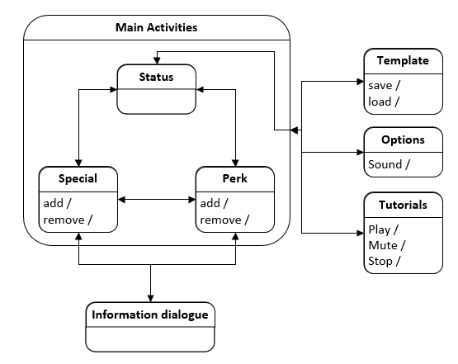

|  |  |  |  |  |  |  |  |
| --- | --- | --- | --- | --- | --- | --- | --- |
| Activity go to | Status | Special | Perks | Inform | Temp | Options | Tutorial |
| Status |  | X | X |  | X | X | X |
| Special | X | X | X | X | X | X | X |
| Perks | X | X | X | X | X | X | X |
| Inform |  | X | X |  |  |  |  |
| Temp | X |  |  |  | X | X | X |
| Option | X |  |  |  | X | X | X |
| Tutorial | X |  |  |  | X | X | X |

(Guru99)

## Expected Results of Tests

|  |  |  |
| --- | --- | --- |
| Activity | Tests | Expected |
| Status | 1. Move all available activities | 1: Navigate to Special 1: Navigate to Perks 1: Open menu and go to Temp, Options, Tutorials |
| Special | 1. Move to all Available activities 2. Open extra information 3. Add or remove a perk | 2: Navigate to Status 2: Navigate to Perks 2: Open menu and go to Temp, Options, Tutorials 3: Open and information dialog box 4: Special can be added or removed, and page changes |
| Perks | 1. Move to all Available activities 2. Open extra information 3. Add or remove a perk | 5: Navigate to Status 5: Navigate to Special 5: Open menu and go to Temp, Options, Tutorials 6: Open and information dialog box 7: Special can be added or removed, and page changes |
| Information | 1. Information dialog can leave back to Special or Perks | 8: Exited to Special 8: Exited to Perks |
| Template | 1. Move to all Available activities 2. Save and load a template | 9: Exit to status 9: Open menu and go to Options, Tutorials 10: Save a template 10: Load a template |
| Option | 1. Move to all Available activities 2. Change volume 3. Mute sound | 11: Exit to status 11: Open menu and go to Temp, Tutorials 12: Lower volume and increase volume 13: mute sound, unmute sound |
| Tutorial | 1. Move to all Available activities 2. Pause or skip video 3. Mute sound on video | 14: Exit to status 14: Open menu and go to Temp, Options 15: Pause and skip, Play and Skip 16: mute sound and unmute sound |

# Usability Testing Procedure

## Introduction

This will test whether the design of the program to be easy to navigate and if features are easy to use. I need to prepare the scenario and inform the user of any pertinent information. The test should be timed based on some criteria of achievement.

### User Criteria

The audience just needs to be the right age and have preferably played the game.

* Must be between 18-30
* Must have some knowledge of the fallout games

Other demographics won’t be necessary for this prototype since there is not a chat feature or pricing model.

## Methodology

### Use Case Scenario 1:

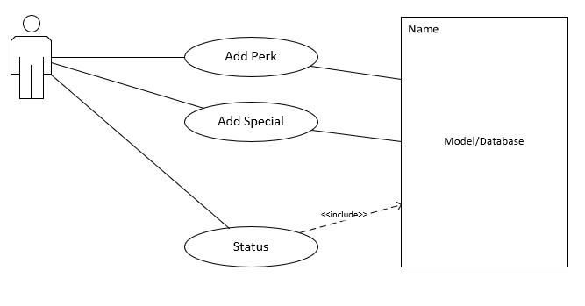

1. From status navigate to special
2. Can the user add to a generic special and a specified one?
3. Can the user add a generic perk and a specified one?
4. Can the user see the relevant changed on status?

### Use Case Scenario 2:

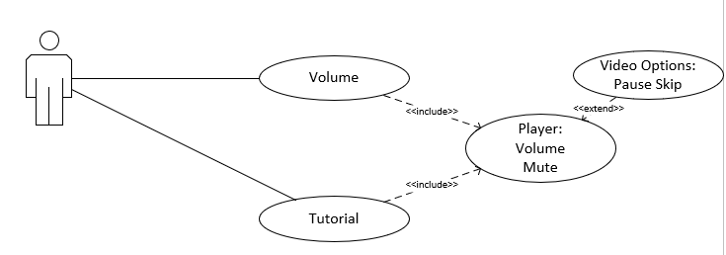

1. From status navigate to Options(volume)
2. Can the user lower the volume and then mute it?
3. Can the user play the video in the Tutorial?
4. Can the user Lower the volume and mute the player?
5. Can the user pause the video and skip to the end?

## Expected Result of Tests

### Use Case Scenario 1:

Condition:

* Phone is powered
* App is loaded
* Left on status activity
* Instructions left for user

Main Scenario:  
User follows instructions

* They navigate to Special
* They add any Special
* They add a specified Special: one that has an impact on status
* They navigate to Perks
* The add any Perk
* They add a specified Perk: one that has a separate impact on status
* They navigate to Status and leave the phone

Expect: The status page to have the changed set by adding a special and perk

### Use Case Scenario 2:

Condition:

* Phone is powered
* App is loaded
* Left on status activity
* Instructions left for user

Main Scenario:  
User follows instructions

* They navigate to Options (Volume)
* They lower the volume
* They mute the volume
* They navigate to Tutorials
* The play the video
* They lower the video volume
* They mute the video
* They pause the video
* They skip the video to the end
* They leave the phone

Expect: The video and audio setting should retain the changes

# Deliverables

Three Testing scenarios

1. Functional Testing: Moving to all available navigation options
2. Functional and Usability Testing: Adding and removing special or perks.
3. Functional and Usability Testing: Media skip, pause, mute and volume options.

# Test documentation

## Functional Test

Function_Test_Checklist.xlsx

## Usability Test

Next page

## Use Cases

Age between 18-30:

How many hours played fallout: A little Average To many hours  
 1-10 hours 10-100hours 100-1000hours

### Case 1

#### Instructions

1. From Status navigate to Special
2. Once in Special add a point to any Special trait
3. Please add a special point to Agility
4. Then from Special navigate to Perks
5. Once in Perks select and Equip any Perk
6. Then selected and equip the Perk named Lifegiver
7. Then from Perks navigate to Status
8. Leave the phone for assessment

#### Assessment

Time taken ____________

Alternative Paths taken ________________________________

Tasks unable to complete _________________________________

Status Screen Differences: Screenshot

### Case 2

#### Instructions

1. From Status navigate to Options
2. Lower the volume by selecting the volume slider
3. Mute the sound by selecting the mute button
4. Then from Options navigate to Tutorials
5. Play the video by clicking the play button
6. Lower the volume on the video
7. Mute the sound on the video
8. Pause the video
9. Skip to the end of the video
10. Then leave the phone

#### Assessment

Time taken ____________

Alternative Paths taken _____________________________

Tasks unable to complete ________________________________

Tutorial Screen Differences Screenshot

# References

Guru99. (n.d.). *What is State Transition Testing? Diagram, Technique, Example.* Retrieved from www.guru99.com: https://www.guru99.com/state-transition-testing.html